ECE 311: Digital Signal Processing Lab
Lab 1 Matlab Overview
Xuanying Li
Jan 26, 2016

2. Scripts:
Report Item:
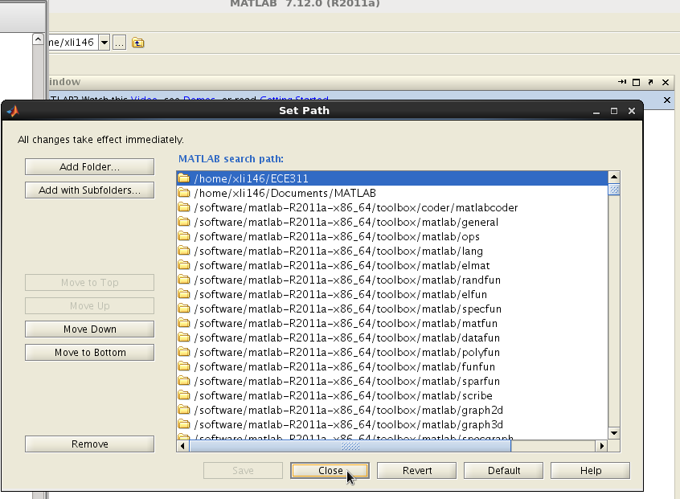
3. Vectors and Matrices
Report Item:
the gap is (2-1)/(12-1) = 1/11;
if the endpoint b is not included, the delta will be ~~~~~~~~~

5. Plots and Labels
Report Item:
Report Item:
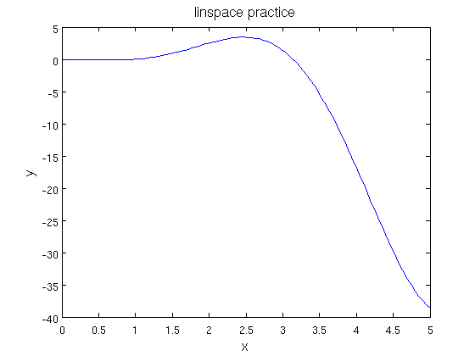
linspace practice :f(x) = x^2log(x)sin(x)
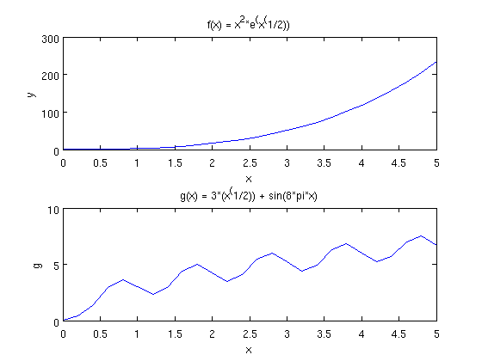
subplot of both functions
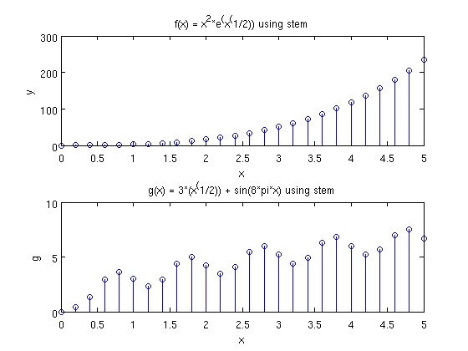
subplot both functions using steam

6. Function
Report Item: Answer of X is
X = 1.0000 8.8262 + 1.5388i -6.8262 - 0.3633i -6.8262 + 0.3633i 8.8262 – 1.5388i
the plots for real and imaginary parts :
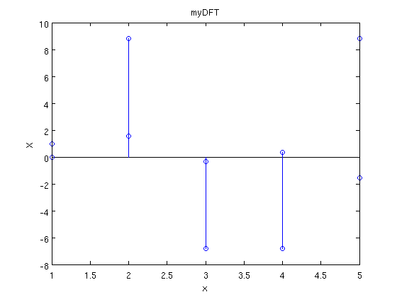
7. Matrix Operations
Report Item:
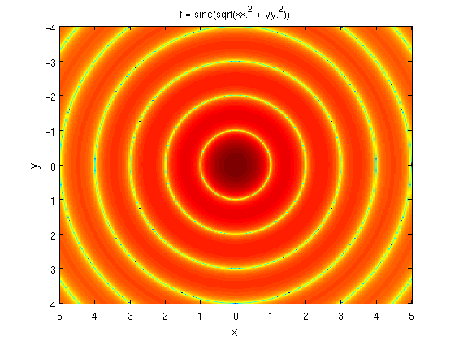
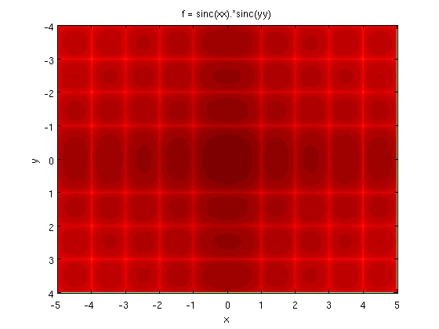
8. Sounds and Images:
Report Item;
I used 9000 hertz for frequency. The range of human hearing is about 20 Hz to 20kHz.

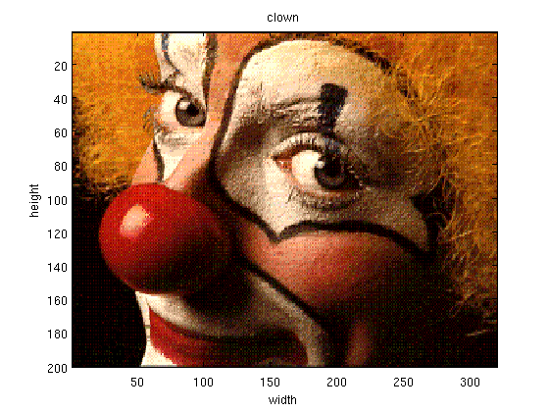
Clown Image

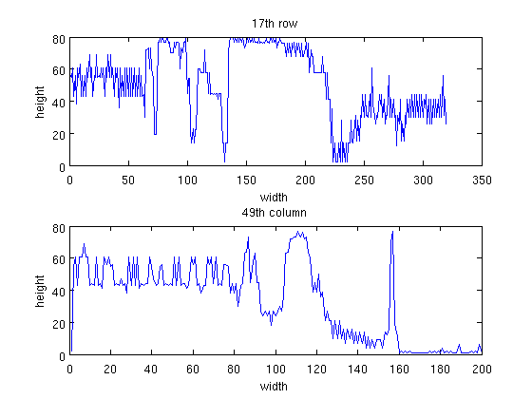
17th row and 49th column of the clown image
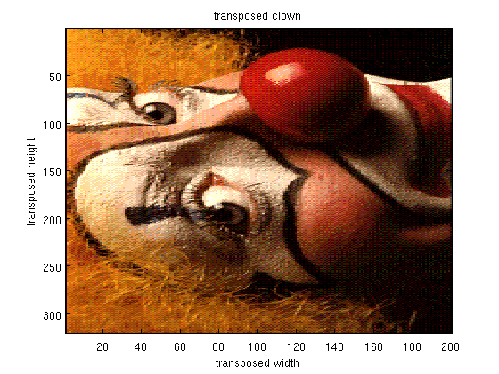
transposed clown image

